**CRUISE CONTROL**

* **Problem Statement:**

Design, fabricate and fly a wireless remote controlled aircraft (using electric motors only), which has all three degrees of freedom including yaw, pitch and roll and that can complete a specified task.

* **Rules and Regulations:**
* **Model Specifications:**
* An aircraft is defined as an object that has the four forces of flight, namely lift, drag, weight (gravity) and thrust due to propeller acting on it at any point of time.
* The Aero model should have a wing span of 120cm maximum
* The Aero model must weigh less than 800 g.
* The model must be hand launched. Use of landing gear is prohibited.
* The aero model must be hand-made.
* For information on design you are advised to visit http://students.iitk.ac.in/aeromodelling.
* A team can use only one model throughout the competition. The same model should be used in all the rounds. In case of any damage, small modifications are allowed.
* Only electrical motors are allowed which will be same for each pool.
* The potential difference, between any two points on the machine, must be lower than or equal to 12.6V at any point of time during the competition.
* The participants are free to use the materials of their choice. However the use of Balsa wood or foam (sun board) or sun pack (coroplast) or thermocole is advisable. Foam is light, easy to handle and fabricate the aircraft making it the best choice. Participants can use Design-Foil software to design the aircraft wing.
* Participants must make all parts of the aircraft themselves. Usage of Ready-to-Fly (RTF) and Almost-Ready-to-Fly (ARF kits is strictly prohibited. Use of readymade actuators/motors, remote controls and propellers is allowed.
* Use of gyroscopes (gyros) is prohibited.
* If anyone is found not following above rules, they will be disqualified. Use of CF rods allowed for strengthening.
* **Judging Criteria:**

Designing of an aircraft is a very important part of this competition. The flight tasks in competition include aerobatics, good controls and speed. So your aircraft should be such that it can perform the given tasks effectively.

* **The tasks for the competition are:**
* Take off and safe landing.
* Flying as fast as you can in addition to taking sharp turns to complete the run in minimum possible time.
* **Qualifying Round :**

The team will qualify for the competition only if the plane is able to takeoff and fly for at least 45 seconds.

* **Round 1: Pylon Racing**

In a given time of 2 minutes (including takeoff ), the aero model will have to complete maximum number of laps between two given checkpoints 75 meters apart. Additional 1 minute will be given to land the plane safely.

* **Scoring**:

N = number of complete laps, N min = min no of laps, Nmax = maximum number of laps

**Total points = 10 + 60[(N – Nmin)/(Nmax - Nmin)] + 10(for safe landing)**

*safe landing: Landing in which no part of plane is damaged or detached except propellers.

* **Round 2: Spot landing**

The participant will have to take off and land the plane in a specific zone. Two attempts of 1 minute duration will be given to each team.

**Points**:

Zone A 20 pts

Zone B 15 pts

Zone C 10 pts

Elsewhere 5 pts

Unsafe landing -10 point

**Points = Best score out of the two attempts.**

Minimum possible score = 0

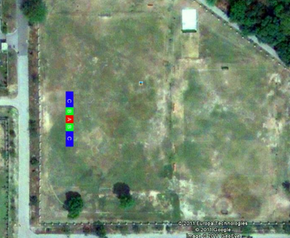

* **Team Specifications:**

Each pool should come up with a maximum of 1 RC plane.

* **Scoring**:

Round 1 : 80 points.

Round 2 : 20 points.

**Total = Round1 + Round2 = 100 points**

**Note: In case of any disputes, the decision of the coordinators would be final and binding to all.**

* **Contacts:**

Arpit Khunteta arpitr@iitk.ac.in +91 8960467870

Deepak Pawar deepaksp@iitk.ac.in +91 8960484303

Suraj Bhamare surajab@iitk.ac.in +91 9793972266

In case of any doubt, contact the secretary of your hall or any of us.